
MBARARA UNIVERSITY OF SCIENCE AND TECHNOLOGY
FACULTY OF COMPUTING AND INFORMATICS
WEBDESIGN AND DEVELOPMENT
PROJECT TITTLE
Farm Trade Platform System.
GROUP12
AYEBAZIBWE DARIUS 2025/BIT/076/PS
NABUKENYA SHARIFAH 2025/BIT/163/PS
KWARISIIMA MONIC 2025/BIT/005
NIWASIIMA CHARLOTTE 2025/BIT/012
AIJUKA FELIX 2025/BIT/026/PS
KAMATSIKO FLORENCE 2025/BIT/107/PS
SANYA KEVIN 2025/BIT/013
OWOMUGISHA ADELLA 2025/BIT/198/PS
ARINDA FAITH 2025/BIT/057/PS
TUMUSIIME ADELLA 2025/BIT/217/PS
KWIKIRIZA BETTY 2025/BIT/136/PS.
INTRODUCTION
When we sat down as a group to think of a project, we wanted to solve a real problem we see every day in Uganda. We realized that Agriculture is a major economic activity in Uganda, especially in rural areas. How ever, farmers often face challenges in accessing reliable markets for their produce. Many depend on middlemen who offer low prices, reducing farmers’ profits.
The Farm Trade Platform System is a web-based solution designed to connect farmers directly with buyers such as traders, restaurants, and individuals. The system improves transparency, pricing, and accessibility of agricultural products.

OBJECTIVES OF THE SYSTEM
Main Objective
- To ensure farmers get fair prices for their produce.
Specific Objectives
- To connect farmers directly with buyers through an online platform.
- To enable farmers to compare prices from different markets.
- To allow farmers to list their produce and receive competitive offers.
- To improve farmers’ decision-making on when and where to sell produce.

SYSTEM DESIGN
The system is designed as a web-based platform with the following components:
User Interface: Allows farmers and buyers to interact with the system (register, login, view products).
Backend System: Handles business logic such as user authentication, product listings, and transactions.
Database: Stores user data, produce listings, prices, and transactions.
Architecture Type: Client-server architecture where users access the system via a web browser.
Site map.
HOME
│
├── About Us
├── Market Prices
│ ├── Kampala Prices
│ ├── Mbarara Prices
│ ├── Gulu Prices
│ └── Mbale Prices
│
├── Buy Commodities
│
├── Sell Commodities
│ └── Farmer Upload Form
│
├── Dashboard
│ ├── Farmer Dashboard
│ └── Buyer Dashboard
│
├── Contact Us
│
└── Login/Register

Wireframe.
Home page wireframe.
Farmer Commodity Upload Form
-------------------------------------
Farmer Name [_____]

Commodity [Dropdown]

Quantity [_____]

City [Dropdown]

Price/kg [_____]

Phone Number [_____]

[SUBMIT BUTTON]

Sell page wireframe
SEARCH COMMODITIES
----------------------------------

[Search Box]

Commodity Listings

--------------------------------------
Maize - Kampala - UGX 1200/kg
Seller Contact: 0776080020
[BUY NOW]

DESCRIPTION OF FEATURES AND TECHNOLOGIES USED
Key Features
- User registration and login
- Farmer profile management
- Produce listing
- Real-time market price display
- Buyer search and browsing
- Direct farmer-buyer communication
- Order and offer system
- Price comparison feature
- Notifications and alerts
- Reports and analytics
Technologies Used
Frontend: HTML, CSS, JavaScript
Backend: Hypertext Preprocessor (PHP)
Database: Database management system (MySQL)
Tools: Web browsers, development environments (vs code)

SCREENSHOTS OF THE SYSTEM.
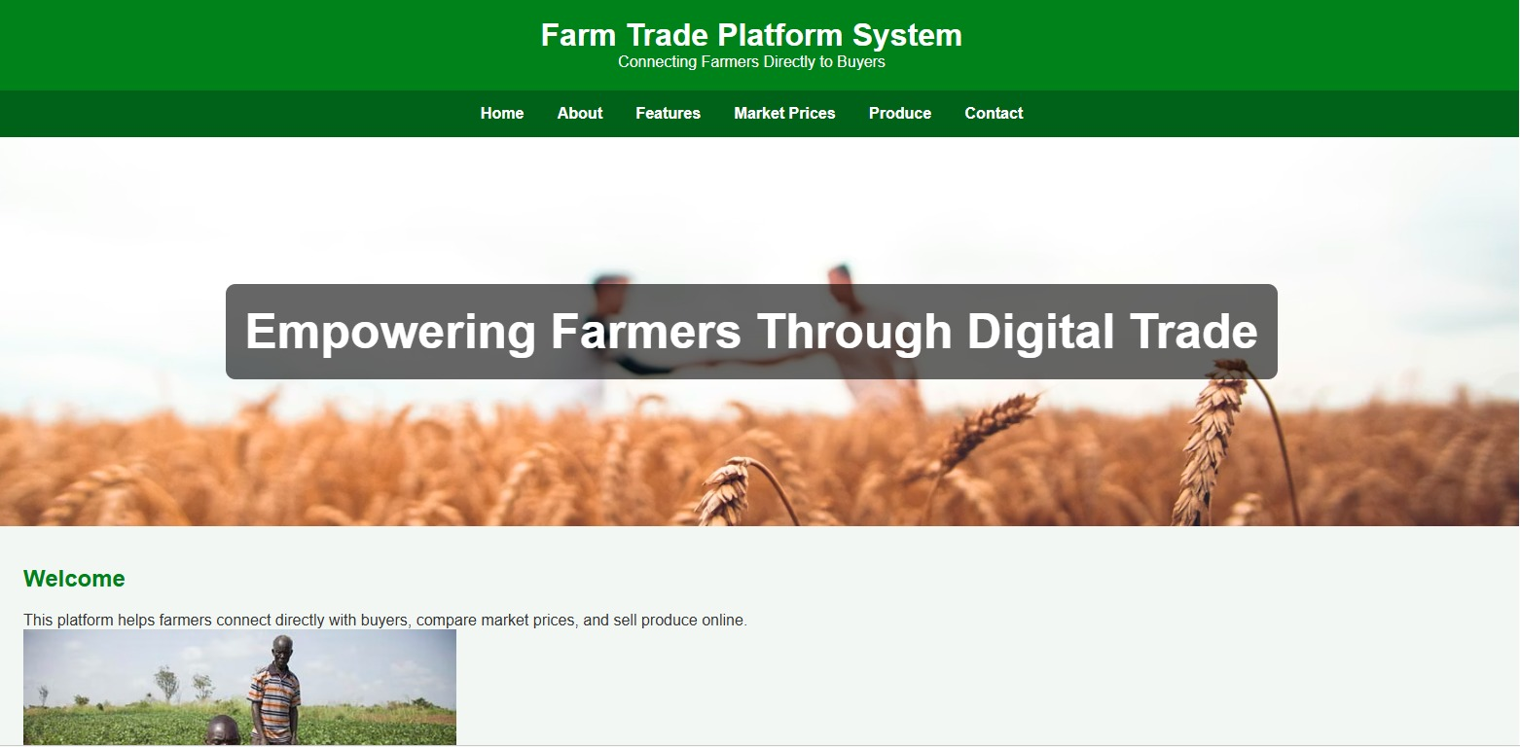
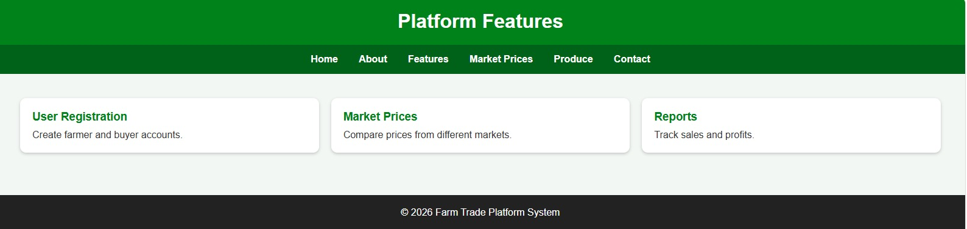

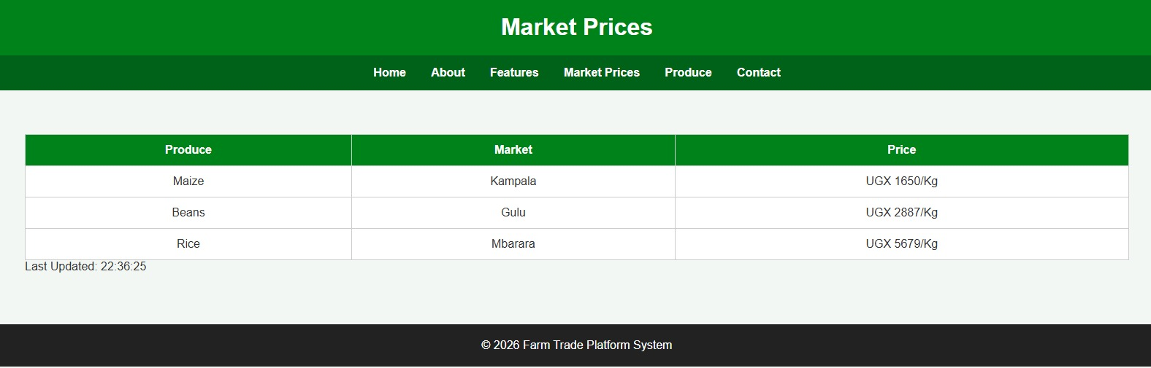

CHALLENGES ENCOUNTERED
- Limited access to real-time market price data
- Difficulty in designing a user-friendly interface for farmers
- Internet connectivity issues in rural areas
- Limited technical experience with some technologies

CONCLUSION
The Farm Trade Platform System provides an effective solution to challenges faced by farmers in accessing markets. By connecting farmers directly with buyers and providing real-time price information, the system improves transparency and helps farmers earn better income.
The project also promotes digital transformation in agriculture and enhances decision-making for farmers, contributing to economic growth and sustainability.

